The basics of Java Program, Variables Data types and comments

{Hello.java} -> compiler -> {Hello.class} (converted to bytecode) -> JVM -> {Hello.class} (machine code)

JVM: JVM (Java Virtual Machine) is an abstract machine that enables your computer to run a java program.

When run run a Java program, Java Compiler first compiles your Java code to bytecode. Then, the JVM translates bytecode into native machine code (set of instructions that a computer CPU executes directly).

JRE:

Java run time environment consists of JVM, Java class libraries and other components that are required to run java application.

JDK:

Java Development Kit us a software development kit required to develop Java applications. It contains JRE, that contains JVM and also a number of development tools such as compilers, JavaDoc, Java Debugger etc

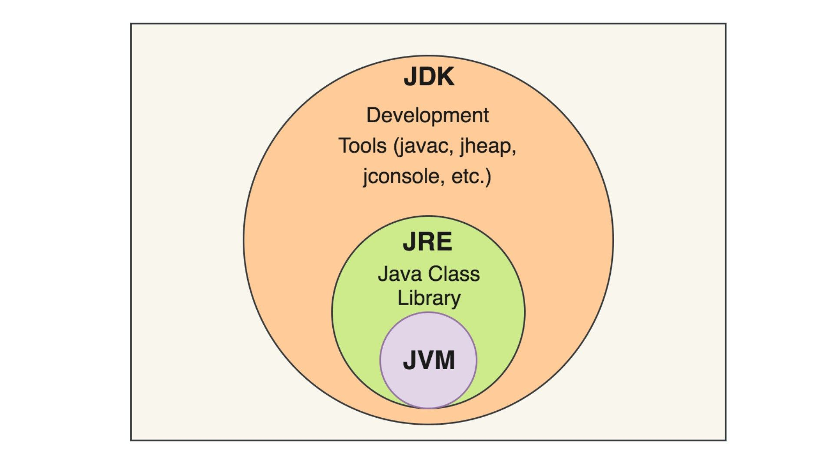

Java Keywords:

Public, static, void, new, package etc

Java Variables: if we are storing anything in the memory, we should give it a name and that name is called a variable. Keywords cannot be used as variables.

Rules for naming variables:

* Java is case sensitive; age and AGE are not the same
* Variables must start with either a letter or an underscore, _ or a dollar, $ sign
* Variables names can’t use whitespace
* Variable names cannot be a keyword.

Binary Number System

* Conversion of Decimal to Binary